**Reported speech**

**1**  Will asked us …………………………… (time / game / start) the next day.

**2**  The assistant asked him if …………………………… (he / like / try) on a smaller jacket.

**3**  My teacher asked me …………………………… (I / finish) the exercise and I said I hadn’t.

**4**  I asked Maria …………………………… (which / film / seen) the night before.

**5**  The dentist asked …………………………… (me / why) never used an electric toothbrush before.

**6**  She asked him if …………………………… (he / going) the park and he said he wasn’t.

**7**  I asked the policeman whether …………………………… (he / help / us) and he said he could.

**5. Somebody says something to you which is not what you expected.**

**1**   A: It’s quite a long way from the hotel to the station. B: Is it? The man on the reception desk said......................

**2**   A: Sue is coming to the party tonight.      B: Is she? I saw her a few days ago and she said she …………………….

**3**   A: Sarah gets on fine with Paul.      B: Does she? Last week you said ……………………. each other.

**4**   A: Joe knows lots of people.      B: That’s not what he told me. He said ……………………. anyone.

**5**   A: jane will be here next week.      B: Oh, really? When I spoke to her, she said ……………………. away.

**6**   A: I’m going out tonight.      B: Are you? I thought you said ……………………. home.

**7**   A: John speaks French quite well. B: Does he? He told me ……………………. any other languages.

**8**   A: I haven’t seen Ben recently.      B: That’s strange. He told me ……………………. last weekend.

**whereas/while**

1. 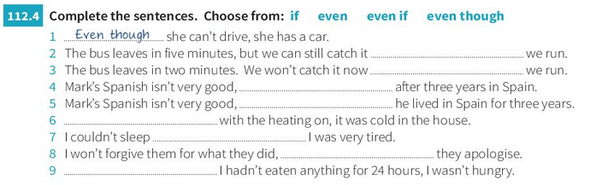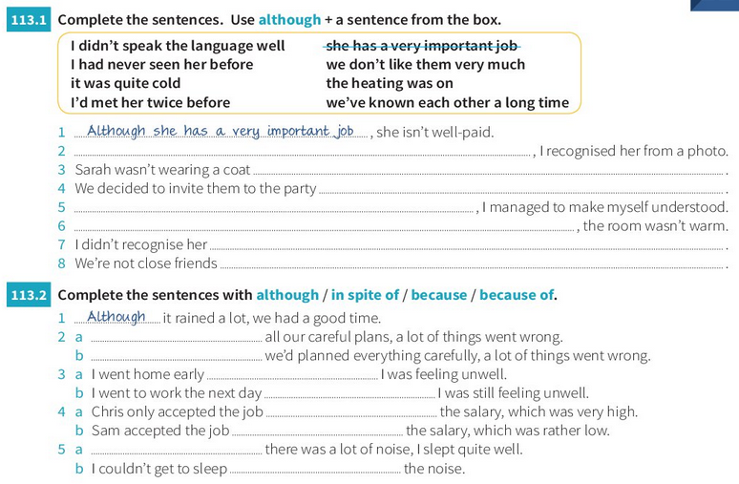Lucy, will you lay the table.................. I help your sister with her maths exercise, please.   
   2. The twins are very different: Paul is shy and reserved.................... Dennis is outgoing.  
   3. He choked .................... he was eating and then had to be taken to hospital for an X-ray.  
   4. At school, I have difficulties with languages.................... I’m very good at Maths.   
   5. Will you watch the baby.................... I’m taking care of getting your luggage ready?  
   6 .Dad would like to have a holiday in Spain .................... Mom would prefer Italy...   
   7. In India, August is quite a cool month.................... it can be quite scorching in Chicago.  
   8. Would you like a soda.................... you’re waiting for Adam?  
   9. My secretary will answer my phone calls.................... I’m away abroad.  
   10. My aunt Sophie is a doctor.................... Uncle Pete is a dentist.